Green Space, Urban Heat, and Residential Equity in Greater Melbourne
Group 14: Weican Wang, Xueying Yuan, Zidan Zi, Ziyu Xu

Introduction
This project focuses on the relationship between green space, regional climate environment and residential equity in Greater Melbourne. Green space plays a crucial role in cities, not only providing important spaces for residents' daily leisure and activities, but also helping to cool down, improve microclimate and alleviate the urban heat island effect to enhance the quality of the living environment (World Health Organization Regional Office for Europe, 2016). However, the distribution of green resources in different areas is not balanced, and this disparity will further affect the quality of life of residents in the region.
Urban green space is widely regarded as an important spatial resource for improving the urban living environment. It not only provides residents with leisure, sports and social spaces, but also helps to alleviate the urban heat island effect (Zhou et al., 2023). For a high-density city like Melbourne, the distribution of green space is closely related to residents' health, comfort and climate adaptability. Currently, the cooling function of green space has become an important issue in urban sustainable development and climate resilience planning.
However, existing research has pointed out that urban green space resources are affected by land value, planning history, population density and socio-economic conditions. Low-income communities, areas with a large elderly population or high-density residential areas lack sufficient tree cover, parks and open spaces, and are therefore more likely to face the problem of insufficient green space (Sharifi et al., 2021).
This project takes Greater Melbourne as a case study, combining green space area, thermal environment and population socio-economic data to analyze whether green space can improve regional climate conditions and further explore whether this environmental benefit is spatially equitable.

Research Requirements and Analytical Focus
This study will conduct an analysis from three aspects: whether the distribution of green spaces is balanced, whether green spaces have an impact on the regional climate, and whether these green spaces and climate advantages are distributed fairly among different social groups.

2.1 Equitable of distribution of green spaces
This study first needs to analyze the differences in green space distribution among different areas of Greater Melbourne. This part will take suburbs as the spatial unit and compare the green space resources in each area. The main indicators include the total area of green space, green space coverage rate, per capita green space area, as well as canopy coverage or vegetation coverage ratio.
This analysis can help identify which areas have more abundant green space resources and which areas have a shortage of green space.

2.2 The influence of regional climate
This study will also conduct a further analysis to determine whether green spaces have an impact on the regional climate environment, particularly whether they can alleviate the urban heat island effect. Urban green spaces can improve the local thermal environment through shading, evapotranspiration, and reducing hard, impermeable surfaces (Department of Transport and Planning, 2023). Therefore, this project will compare the relationships between green space indicators and climate indicators.
The analysis includes: the relationship between green coverage and surface temperature and heat island intensity. Through these analyses, this study aims to determine whether areas with more green spaces typically have lower heat exposure, and whether areas with less green space are more likely to face higher thermal environmental pressure. It will further explain how green space areas may affect residents' climate environment and living comfort.

2.3 Green space and social equity
Finally, this study needs to analyze whether the advantages brought by green spaces and favorable climate conditions are distributed fairly among different social groups. This part will combine the results of green space and heat environment with population socio-economic data, such as income levels, the proportion of elderly population, the proportion of children population, and population density.
This analysis can answer the question: Are low-income groups, areas with a high proportion of elderly population, areas with a high proportion of children, or high-density residential areas more likely to simultaneously face the risk of insufficient green space? If these phenomena exist, it indicates that the environmental benefits brought by green spaces may not have been fairly shared in the Greater Melbourne region.
By combining environmental indicators and social indicators, this project can identify the areas that need priority attention. For example, some areas may simultaneously have low green coverage, high heat exposure, and high social vulnerability. These areas can be regarded as the key targets for future urban greening, improvement of public open spaces, and climate resilience planning.

Proposed Data Sources
Table 1 shows the datasets that will be used in this project and explains how each dataset supports the analysis. The selected datasets cover the required spatial data types, including polygon, point and raster data, as well as Census attribute data. This allows the project to combine environmental and social information at the SA2 level. A detailed list of proposed datasets is provided in Appendix .

Methodology
This project will take the suburbs of Greater Melbourne as the main analysis unit. Firstly, the study will standardize the coordinate system of all data and clip the green space, thermal environment, land cover, and population socio-economic data within the study area. Subsequently, this project will present the basic distribution characteristics of variables such as green coverage rate, surface temperature, income level, and population structure through spatial data visualization, and provide preliminary explanations using maps, histograms, scatter plots, and summary tables.
In further analysis, this project will calculate the total area of green space, green coverage rate, per capita green area, and vegetation coverage ratio for each region, and obtain the average thermal environment indicators for each region through zonal statistics. Afterwards, the study will use correlation analysis and group comparison methods to analyze the relationship between green space indicators and thermal environment indicators, and further compare whether there are differences in the green space and climate advantages enjoyed by regions with different income levels, age structures, and population densities.
Finally, this project will identify the areas with low green coverage, high heat exposure, and high social vulnerability, and create a priority map to provide suggestions for urban greening, improvement of public open spaces, and climate resilience planning in Greater Melbourne.

Simple Map for Proposal
This map shows the Greater Melbourne study area and the spatial distribution of open space data used in this proposal. It provides a basic spatial context for analysing whether green space resources are evenly distributed across different urban areas.

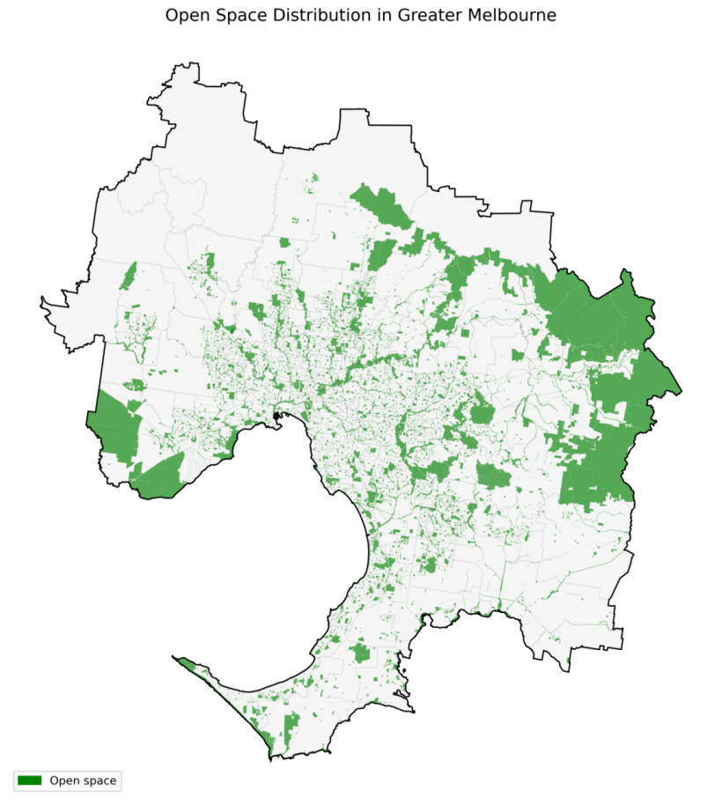
figure 1. Study area and open space distribution in Greater Melbourne

Weekly time-plan
The project will be completed including downloading and cleaning the data to completing the spatial analysis, preparing maps and writing the final report. This plan helps the group manage the project progress more clearly.Weekly time-plan. A detailed weekly project time plan, table 2 is provided in Appendix .

Reference
Department of Transport and Planning. (2023). Melbourne’s vegetation, heat and land use data. Victorian Government. https://www.planning.vic.gov.au/guides-and-resources/Data-spatial-and-insights/melbournes-vegetation-heat-and-land-use-data
Sharifi, F., Nygaard, A., Stone, W. M., & Levin, I. (2021). Accessing green space in Melbourne: Measuring inequity and household mobility. Landscape and Urban Planning, 207, Article 104004. https://doi.org/10.1016/j.landurbplan.2020.104004
World Health Organization Regional Office for Europe. (2016). Urban green spaces and health: A review of evidence. World Health Organization. https://www.who.int/europe/publications/i/item/WHO-EURO-2016-3352-43111-60341
Zhou, W., Wang, J., & Cadenasso, M. L. (2023). How can urban green spaces be planned to mitigate urban heat island effect under different climatic backgrounds? Science of the Total Environment, 879, Article 163107. https://doi.org/10.1016/j.scitotenv.2023.163107

Appendix
Data source | Data type | Key variables | Use in project
ABS SA2 Boundary 2021 and Greater Melbourne boundary | Polygon | SA2 code, SA2 name, boundary geometry | Defines the study area and main analysis units.
ABS 2021 Census DataPack, SA2 level | Aspatial attribute | Population, age structure, income | Measures social vulnerability and population structure.
DataVic Open Space Metropolitan Melbourne | Polygon | Open space boundary, area, open space type | Calculates open space area, green space coverage and green space per capita.
Vicmap Vegetation — Tree Urban Point | Point | Urban tree point locations | Calculates tree density in each SA2 as an additional greening indicator.
Landsat 8 Collection 2 Level-2 Surface Temperature / Reflectance | Raster | Land surface temperature, red band, near-infrared band | Calculates raster-based heat exposure and NDVI, then aggregates them to SA2 level.
Metropolitan Melbourne Urban Heat Islands and Urban Vegetation 2018 | Polygon / supporting environmental layer | UHI value, vegetation cover, canopy information | Supports comparison of urban heat and vegetation patterns across Greater Melbourne.
Table 1. Proposed datasets

Table 2. Weekly project time plan
Week | Planned tasks
Week 10 | Finalise datasets, download boundary, Census, open space, tree point and raster data. Prepare study area and check coordinate systems.
Week 11 | Complete data cleaning and preliminary ESDA. Produce first maps of green space, tree density, heat exposure and Census variables. Present proposal to demonstrator and adjust the project based on feedback.
Week 12 | Complete main spatial analysis, including spatial overlay, spatial join, zonal statistics and correlation analysis. Start building the priority index.
Week 13 | Finalise priority map, interpret results, write discussion and limitations. Prepare final notebook and report figures.
Week 14 | Complete final report, clean notebook structure and comments, prepare video presentation and final submission package.

